Antenna couplers for 144 and 432 MHz

Stefan Heck, LA0BY, 28 January 2001

Purpose

In order to achieve more antenna gain, two or more yagi antennas are often combined to a larger array. The interconnection is normally performed with coaxial cables, although open feeder offers smaller losses. The power delivered by the transmitter has to be split equally between all antennas. Any power or phase unbalance will inevitably reduce the overall performance.

Theory

The heart of such system is a coaxial λ/4-transformer with 50 Ω ports. For a transmission line of that length the input impedance Z_{I} is transformed to the output impedance Z_{O} depending on the transformer line impedance Z_{L}:

Z_{L} ² = Z_{I} × Z_{O}
Z_{L} , L = λ/4
Z_{I} =>
Z_{O}

The transformer can be constructed from coaxial cable or rigid coaxial line. The latter offers lowest loss and a larger variety of line impedances. A rigid coupler is often also mechanically more stable.
D
d
Outer tube
Inner tube or rod
A rigid transformer is made from a
square outer aluminium tube,
and a round inner tube or solid rod.
The line impedance will depend on
the ratio between the inner diameter
D of the outer tube and the outer
diameter d of the inner tube.

The formula for the impedance of such rigid line has frequently been quoted wrong in the literature. The correct expression for Z_{L} is:

Z_{L} = 138 × log₁₀ (D/d) + 6,48 - 2,34 × A - 0,48 × B - 0,12 × C

Where the terms A, B and C are defined as:

A = (1 + 0,405 / (D/d)⁴) / (1 - 0,405 / (D/d)⁴)

B = (1 + 0,163 / (D/d)⁸) / (1 - 0,163 / (D/d)⁸)

C = (1 + 0,067 / (D/d)¹²) / (1 - 0,067 / (D/d)¹²)

Construction principle - Type 1
L = λ/4
Antenna 1
Antenna 2
Transmitter

The antenna impedances are paralleled in one point, resulting in an impedance of only 25 Ω. The λ/4-transformer has to match this to the 50 Ω transmitter cable. According to the formula above, the required line impedance is 35,4 Ω.

Construction principle - Type 2

L = λ/4
Antenna 1
Antenna 2
Transmitter
L = λ/4

Here is the antenna impedance first transformed to 100 Ω, because this is what is needed to achieve 50 Ω at the feed-point where both arms are paralleled. The total length is twice that of Type 1. The required line impedance is 70,7 Ω.

Practical examples

Coupler type | req. Z_{L} | Frequency | L | D | d | real Z_{L}
2-way Type 1 | 35,4 Ω | 144 MHz | 52,1 cm | 26 mm | 15 mm | 36,3 Ω
2-way Type 1 | 35,4 Ω | 432 MHz | 17,5 cm | 26 mm | 15 mm | 36,3 Ω
2-way Type 2 | 70,7 Ω | 432 MHz | 17,2 cm | 17 mm | 6 mm | 65,9 Ω
2-way Type 2 | 70,7 Ω | 432 MHz | 17,2 cm | 17 mm | 5,5 mm | 71,2 Ω
4-way Type 2 | 50,0 Ω | 144 MHz | 51,2 cm | 21 mm | 10 mm | 47,9 Ω

The computed λ/4 lengths are 52,1 cm for 144 MHz and 17,4 cm for 432 MHz. The last coupler was made a little shorter, because two PTFE washers were used to mechanically support the centre conductor.

The measurement results were obtained by using an Agilent (HP) ESA Spectrum Analyzer with integral Tracking Generator. The directional coupler was a home-made construction with only 18 dB directivity on 144 MHz and perhaps 16 dB on 432 MHz.
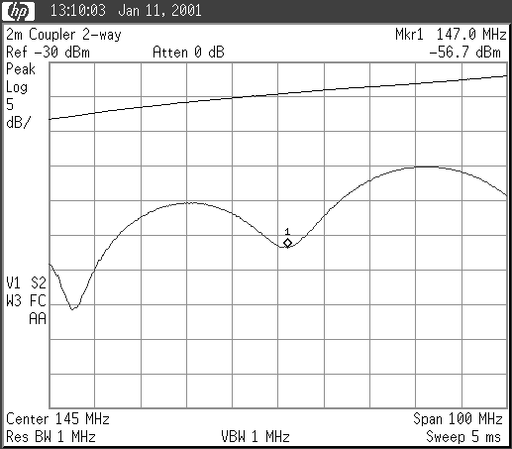 | 144 MHz 2-way coupler, type 1  The upper trace shows the forward power, the lower the reflected power at the common port when all antenna ports were terminated with 50 Ω. The difference is the Return Loss (RL).

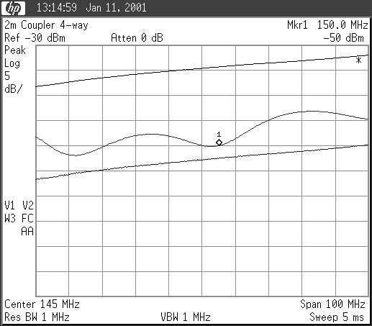 | 144 MHz 4-way coupler, type 2  Here is an additional trace at the bottom that shows the measurement limit determined by the directional coupler directivity.  The 4-way coupler seems to be a little too short.

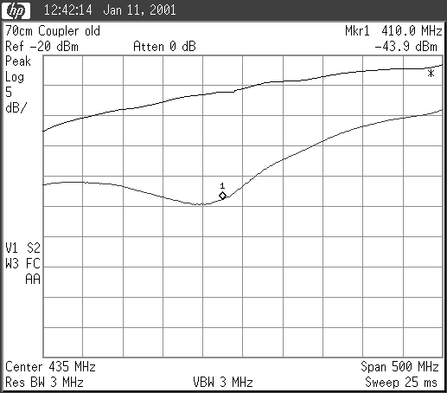 | 432 MHz 2-way coupler, type 1  The coupler seems to be a little too long. The RL result is probably not correct because it is too close to the system limit.

The first 70 cm 2-way coupler of Type 2 was built with 6 mm centre tube due to the wrong formula for the line impedance. No plot of that coupler is shown, though. The RL really improved considerably when changing the centre tube to 5,5 mm.
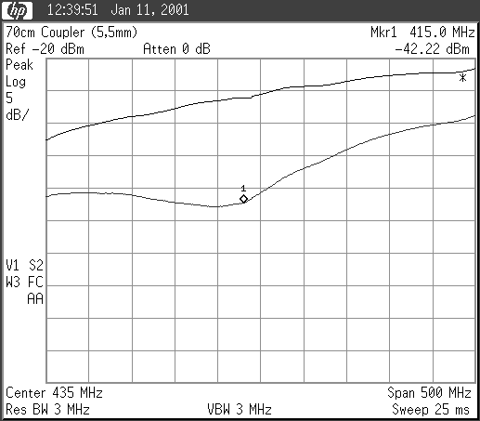 | 432 MHz 2-way coupler, type 2  Here the frequency for best match seems to be a little on the low side. The antenna ports were as previously terminated with 50 Ω loads.

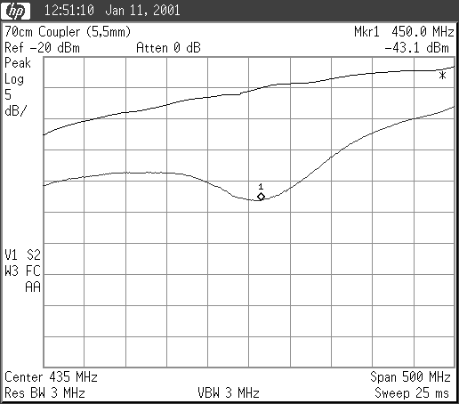 | 432 MHz 2-way coupler, type 2  The same coupler was measured again while the antenna ports were terminated with 10 dB attenuators (corresponding to 20 dB RL). Now the frequency for optimum match seems to be slightly higher.

Generally a RL of much better than 20 dB should be achievable if tubes with proper dimensions are used. The coupler is rather broadband and small inaccuracies in the coupler length will not spoil the performance. The unbalance and also the coupler loss are typically less than 0,1 dB.

How to mount the centre conductor?

The inner conductor is often made from a brass tube that is soldered to the N-contacts. Brass should be polished and protected from corrosion by varnish or plastic spray. However, it is sometimes not easy to find one with the correct diameter. Also the access to the common port for Type 2 is difficult. I found it more convenient to use aluminium rods that can be obtained with diameters in 0,5 mm steps.

Aluminium cannot be soldered easily but M3-taps are drilled into the ends. Soldering lids are attached there with screws. The centre rod is split in two. The lid is soldered to the common contact at the proper position. The two halves are screwed together using an M3 bolt without head in the middle. If a slot is cut into the outer end of the rod a screwdriver can be used to tighten the two halves easily.

Phasing cables

The cables between coupler and antenna should all have the same electrical length. In order to minimise losses t is a good idea to keep the cables as short as possible, but the length itself is not critical. Provided the cables are all from the same production batch it is sufficient to cut them equal in mechanical length. With some care one should be able to achieve an accuracy of better than 5 mm, corresponding about 5° phase difference on 432 MHz.

